**1.3 Applying Software Engineering Approach**

The goal of system design is to produce a model or representation that exhibit, commodity and delight. It provides information about the application domain for the software to be built. It fully describes the internal details of each software. Here are some advantages of incremental model:-

1. Each iteration passes through the **requirements, design, coding and testing phases.**
2. Software will be generated quickly during the software life cycle.
3. It is flexible and less expensive to change requirements and scope.
4. Customer can respond to each built and errors are easy to be identified.
5. 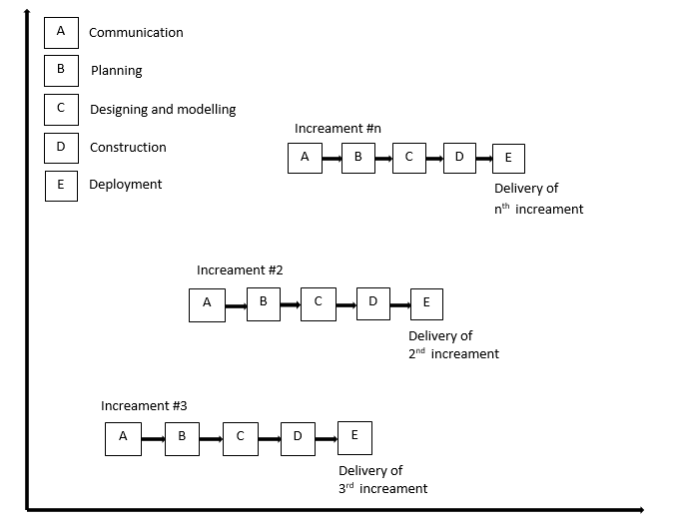Easier to test and debug during a smaller iteration.

Fig.1.3.1: Incremental Model